**© 2015 – Foxes Team**

<http://process.ws>

**Abstract**

This document help team member know how to conduct to collect & analyze metrics in project.

**Measurement Management Process**

**Foxes Project**

**Table of Contents**

1. Introduction 2

1.1. Purpose 2

1.2. Scope 2

2. Process Visual Diagram 2

3. Roles & Responsibilities 2

4. Process Description 3

4.1. Define Procedures Activity 3

4.2. Collect Data 3

4.3. Analyze Data 3

4.4. Evolve process 4

Revision 5

# Introduction

## Purpose

* Providing guidance and procedures for project team to establish metrics for collect data and use them for analyzing, tracking, control the project activities and reports.
* Analyzing result to improve progress of project, quality of product, …

## Scope

This measurement process associated with all phase in management project and development product.

# Process Visual Diagram

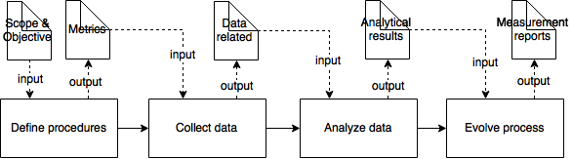

Figure 1: Measurement Process Visual Diagram

# Roles & Responsibilities

|  |  |
| --- | --- |
| Role | Responsibilities |
| Project Management | * Define metrics to collect in Software Management Project. * Collect data related with progress of project. |
| Requirement Lead | * Collect data related with customer satisfaction. |
| Test Lead | * Collect data related with quality of product. |
| Team Member | * Track time fully on Redmine. * Do team morale survey fully. |
| Customer | * Do survey which is provided by Foxes Team. |

Table 1: Roles & Responsibilities

# Process Description

First, the team must identify scope activity includes identification of objectives, measurement, issues involved to meet these objectives, and measures that provide insight into these issues.

This step produces a set of measures to address the need for measurement and the complete set of identified measures is obtained from the Identify Scope Activity

## Define Procedures Activity

* Identify what data are to be collected.
* Define how the data are to be collected and reported.
* Define how the data are to be used to make decisions.
* Define how the process is to evolve and improve and
* Identify who will collect, enter, store, maintain, verify, and have access to the data.

## Collect Data

Using the operational definition of the measurement procedures, data are collected, recorded, and stored.

## Analyze Data

This activity consists of analyzing the data to prepare the reports, presenting the reports to the audience, and reviewing procedures for accuracy and adequacy.

## Evolve process

The Evolve Process Activity is used to improve the process and ensure that there is a structured way of incorporating issues and concerns into improvement of the process.

At this point, the audience receives the measurement reports, and makes decisions based on the data. These decisions may involve re-planning, corrective action, or simply moving on without change.

# Revision

|  |  |  |  |
| --- | --- | --- | --- |
| # | Date | Editor | Description |
| 2 | Sep 6th, 2015 | Tỷ Trần | * Updating with the new template. * Adding some of table description. |
| 1 | Aug 21th, 2015 | Hồng Nguyên | * Establish the first revision |